Front-End UI/UX Mini Project

**1.Title Page**

Project Title: “Restaurant Landing Page.”

* + **Submitted By**:

*Team Members :*

1. *Anna Binoy Augustine : 2462040*

[*anna.binoy@btech.christuniversity.in*](mailto:anna.binoy@btech.christuniversity.in)

1. *Liya Stanly : 2462109*

[*liya.stanly@btech.christuniversity.in*](mailto:liya.stanly@btech.christuniversity.in)

1. *Vyshna Biju : 2462172*

[*vyshna.biju@btech.christuniversity.in*](mailto:vyshna.biju@btech.christuniversity.in)

* + ***Course****: UI/UX Design Fundamentals*
  + ***Instructor Name****: Mr. Narendra*
  + ***Institution****: Christ University*
  + ***Date of Submission****: 12/08/2025*

# 2.Abstract

This project focuses on designing and developing a visually appealing, fully responsive single-page website for a fictional restaurant named The Golden Spoon. The landing page is crafted to provide visitors with an engaging digital experience that reflects the restaurant’s warm and inviting ambiance. Key sections include a bold header with navigation, an immersive hero image with a welcome message, a structured menu showcasing starters, mains, and desserts, an “About Us” segment with a short story and imagery, and a contact section featuring address, phone, hours, and social links.

# 3.Tools & Technologies Used

- Design a single-page restaurant website highlighting menu and contact details.  
- Apply layout techniques (Flexbox/Grid) to create visual appeal.  
- Implement thematic branding using typography and imagery.  
- Use semantic HTML5 structure for content organization.  
- Incorporate hover effects for interactivity.

# 4.Scope of the Project Tools & Technologies Used

- Focused only on front-end development (HTML & CSS).  
- Designed for desktop, tablet, and mobile views.  
- Includes high-quality food images and brand-specific color themes.  
- No JavaScript or backend integration.  
- All assets are open-source or custom-created.

# 5. Tools & Technologies Used

|  |  |
| --- | --- |
| Tool/Technology | Purpose |
| HTML5 | Markup and content structure |
| CSS3 | Styling and layout management |
| VS Code | Code editor |
| Chrome Dev Tools | Testing and debugging |

# 6.HTML Structure Overview

- Used semantic tags: <header>, <nav>, <section>, <footer>.  
- Sections: Header, Hero Image, Menu (Starters, Mains, Desserts), About Us, Contact, Footer.  
- Navigation menu built with <ul> and anchor links.

# 7.CSS Styling Strategy

- External stylesheet: style.css.  
- Layout: Flexbox for header & footer, CSS Grid for menu items.  
- Warm-toned color palette (#8B4513, #FFD700, #FFF8E7).  
- Hover effects for menu items (zoom-in on image).  
- Mobile-first responsive design using media queries.

# 8.Key Features

|  |  |
| --- | --- |
| Features | Description |
| Responsive Design | Works seamlessly on all devices |
| Menu Card Layout | Grid-based food menu with images |
| Hover Effects | Image zoom on menu hover |
| Contact Icons | Font Awesome icons for address, phone, email |

# 9.Challenges Faced & Solutions

|  |  |
| --- | --- |
| Challenges | Solutions |
| Menu item alignment issues | Used CSS Grid for better control |
| Images not scaling well | Applied object-fit: cover |
| Mobile spacing inconsistencies | Added media queries for padding adjustments |

# 10.Outcome

- Created a clean, brand-consistent restaurant landing page.  
- Improved understanding of Flexbox, Grid, and semantic HTML.  
- Learned effective use of typography and color for thematic branding.

# 11.Future Enhancements

- Add JavaScript for interactive menu filtering.  
- Implement a CSS-only lightbox for food images.  
- Add animations to section transitions.  
- Integrate Google Maps for location display.

# 12.Sample Code

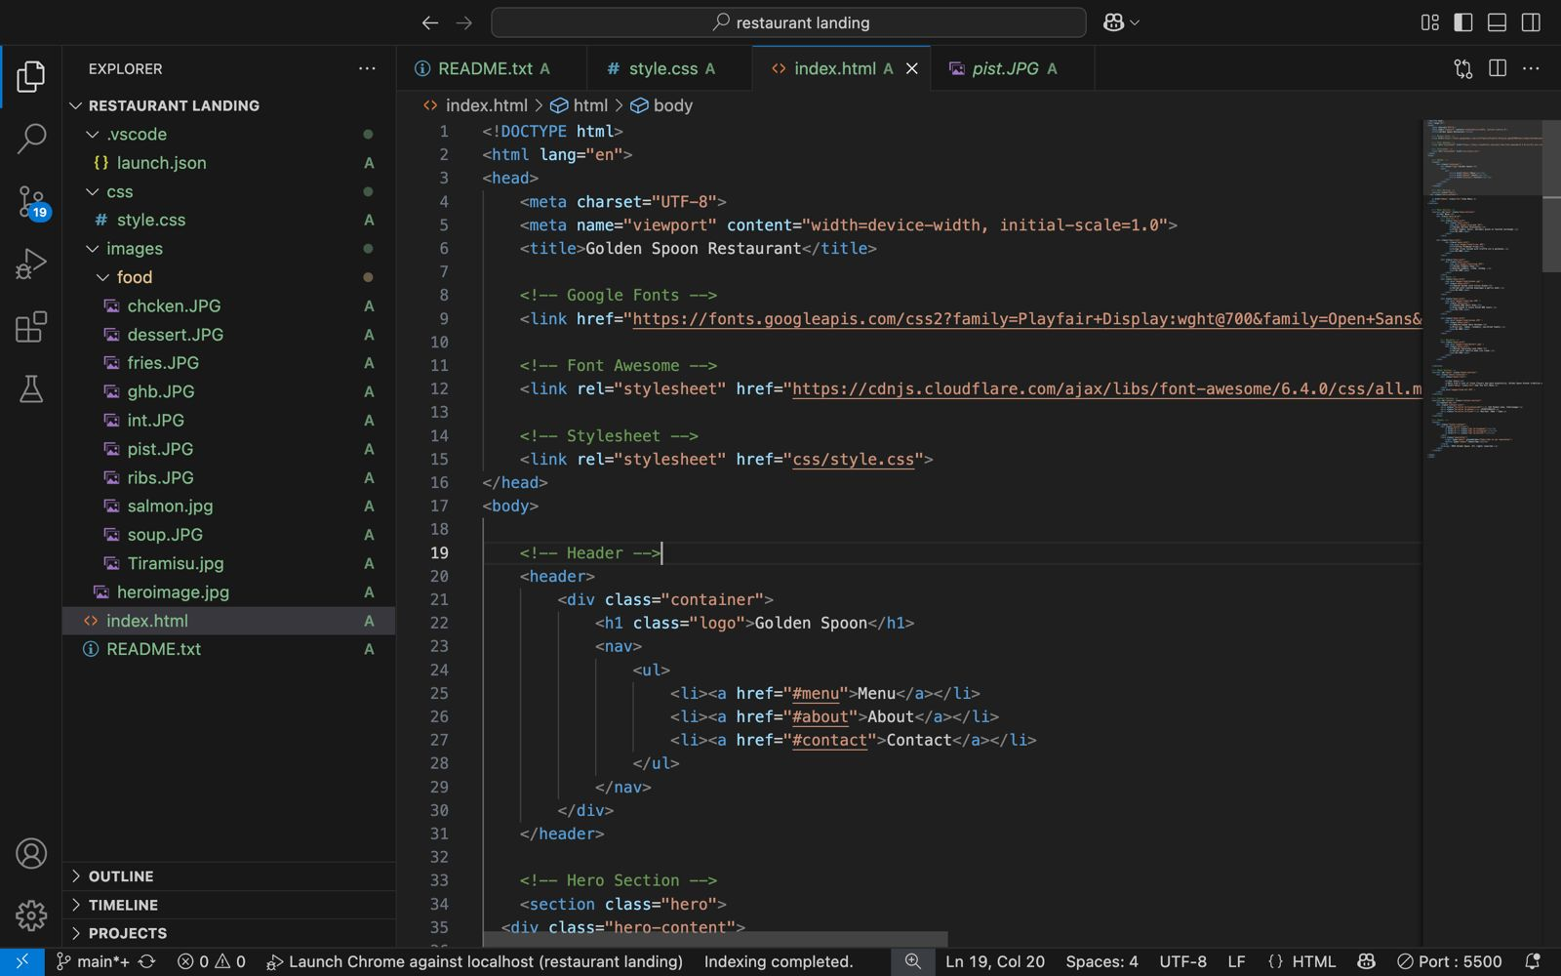

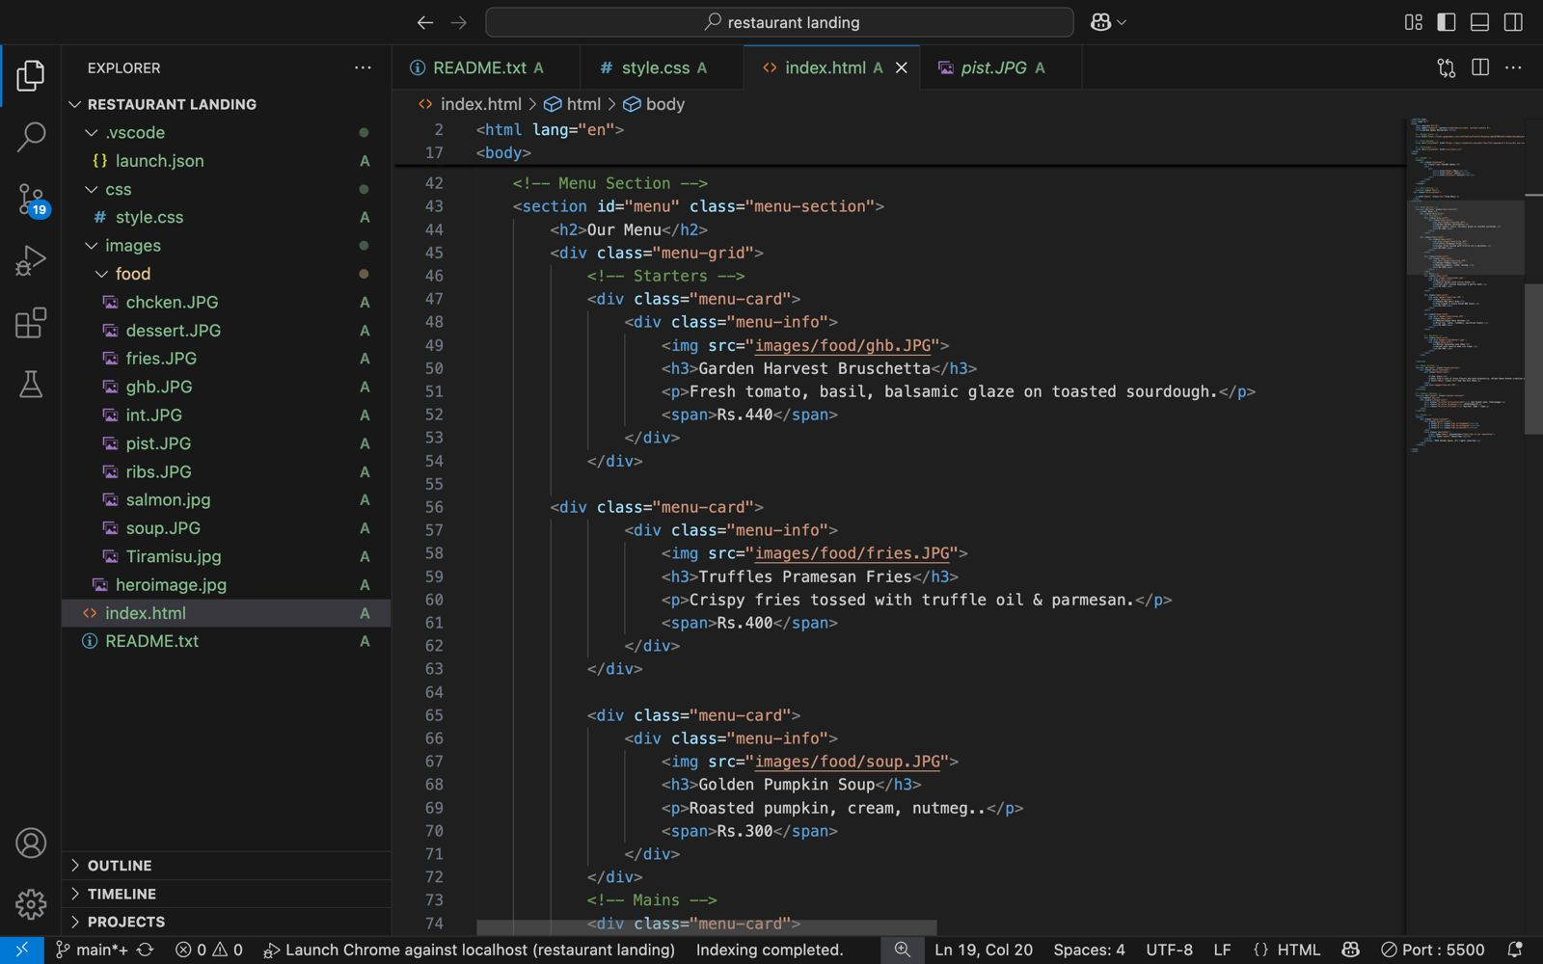

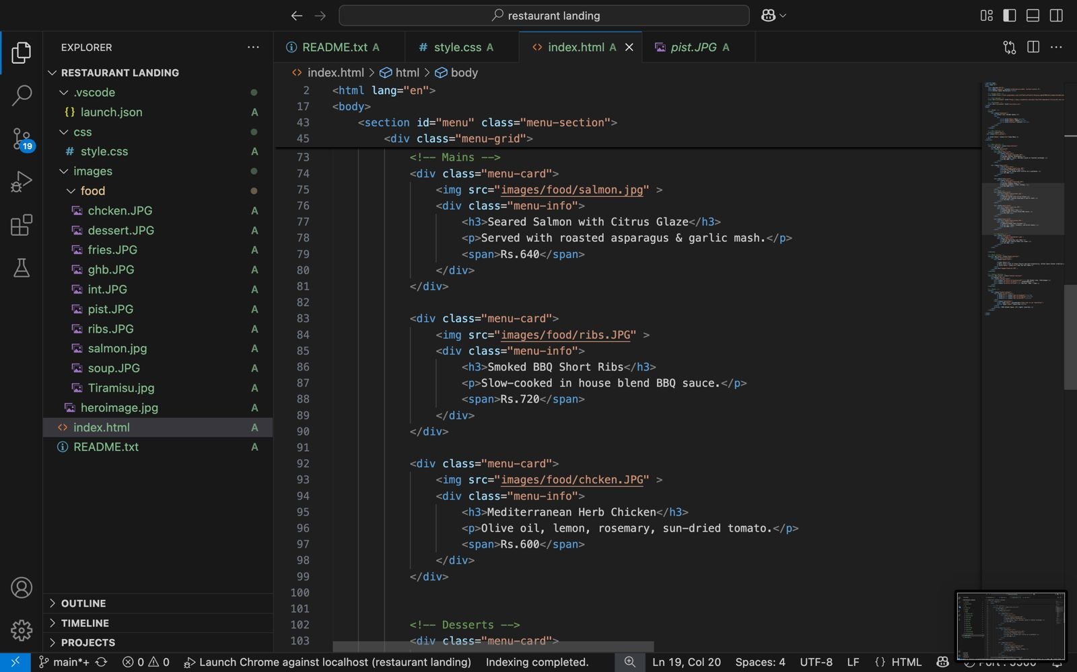

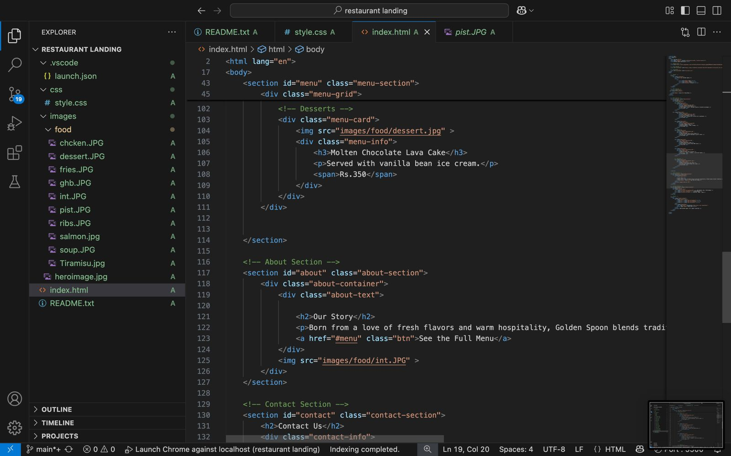

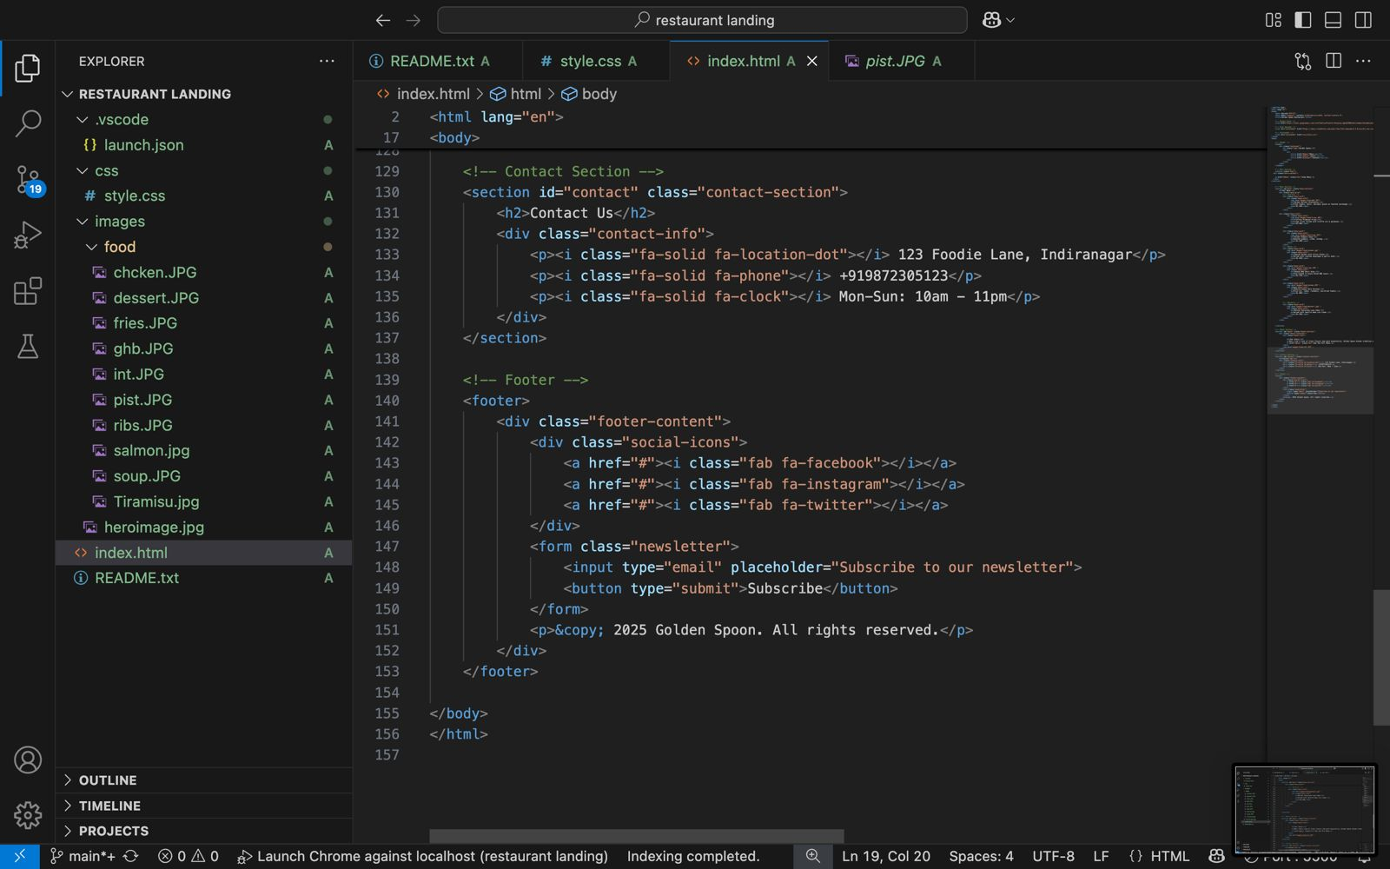

# 13.Screenshot for Final output

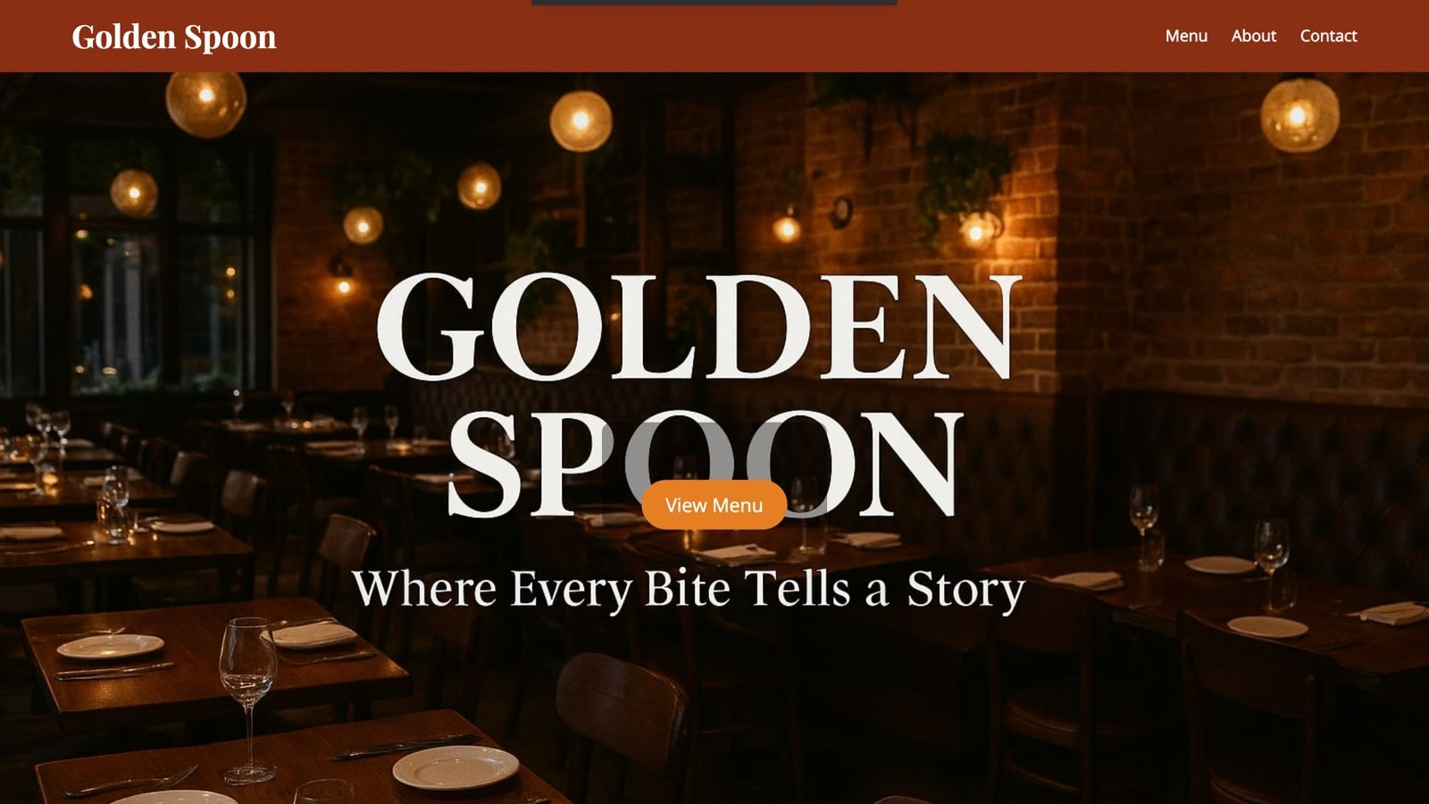

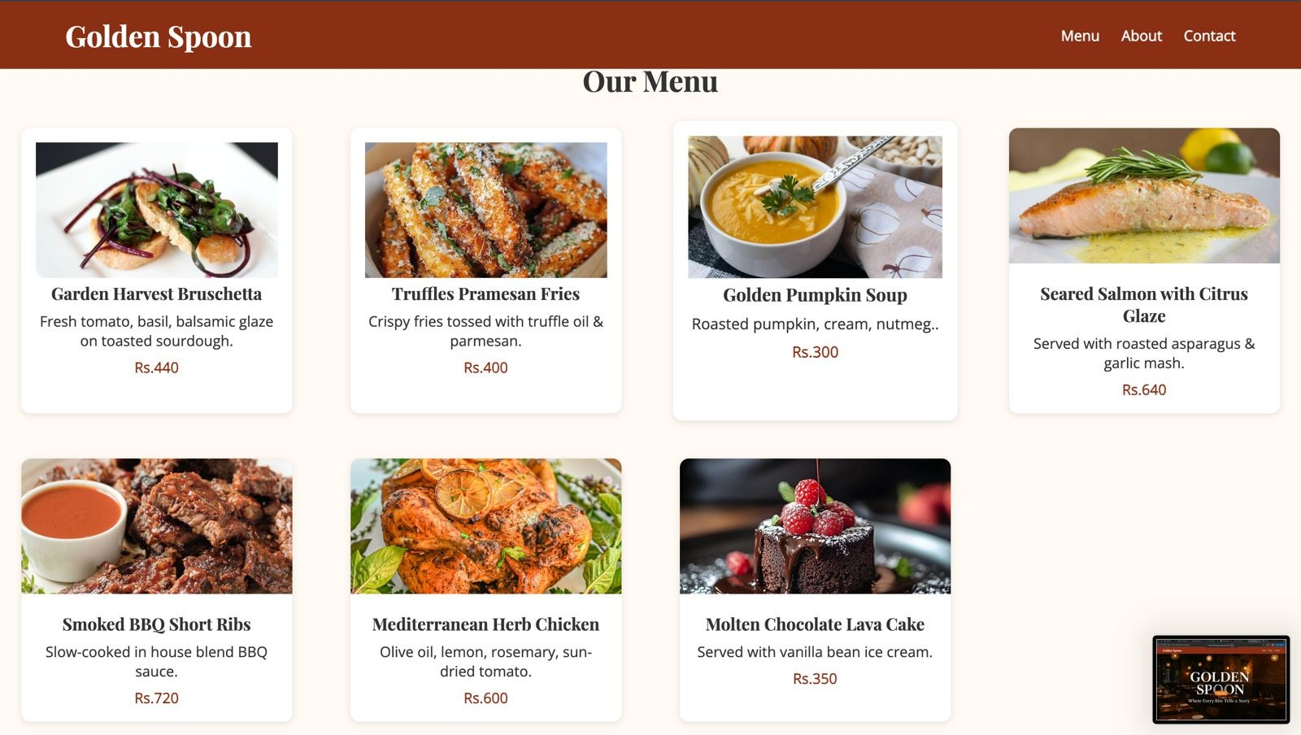

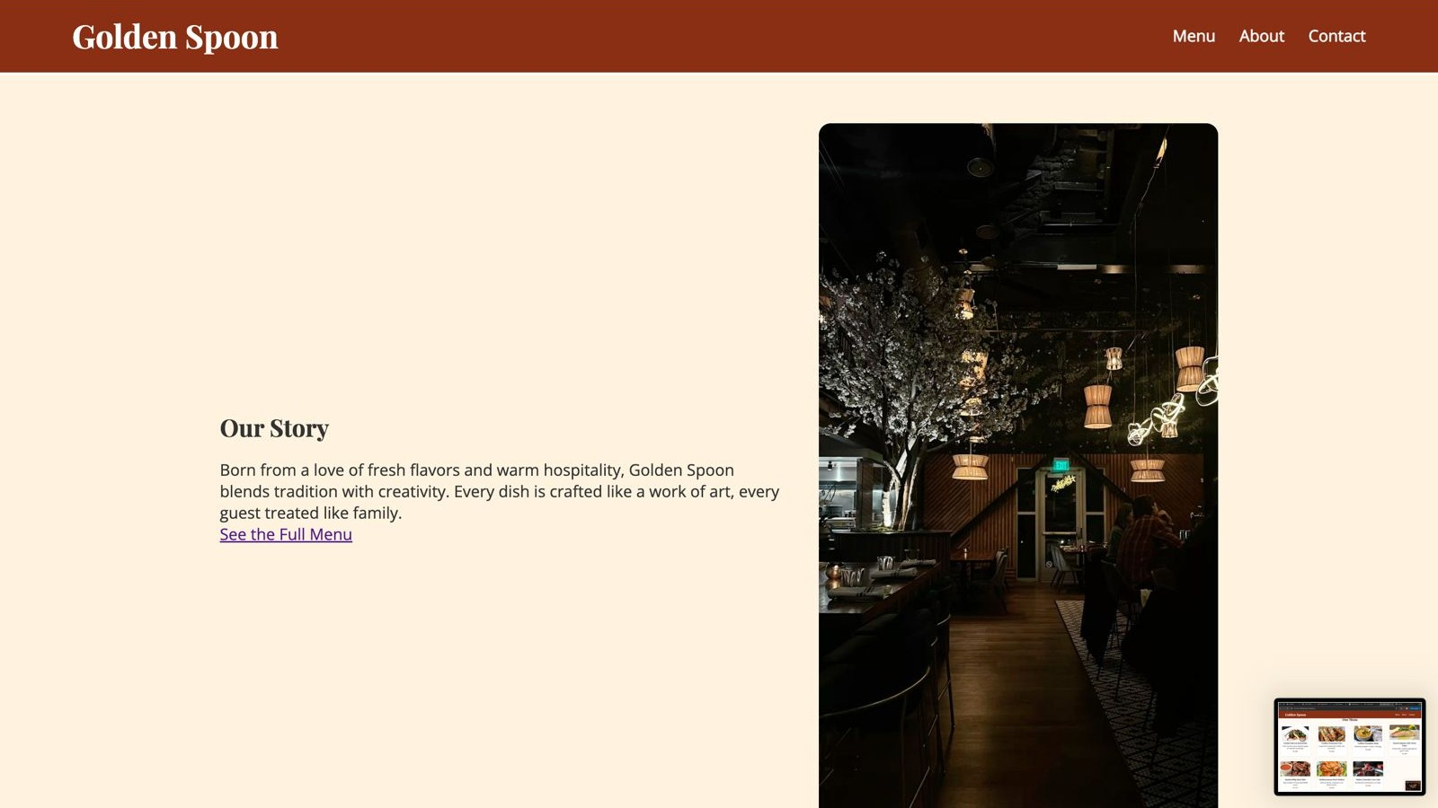

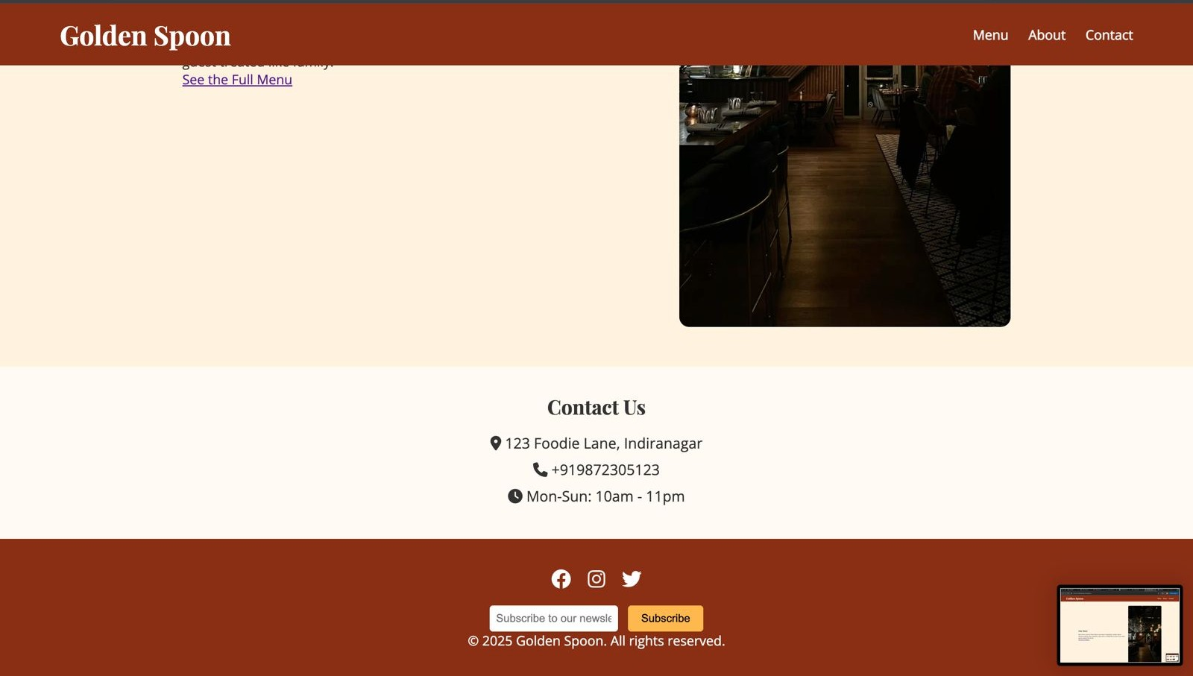

# 14.Conclusion

This project successfully demonstrates the design and development of a responsive, visually appealing restaurant landing page using only HTML and CSS. Through this exercise, I gained hands-on experience in layout design, semantic markup, responsive styling, and thematic branding. The project enhanced my skills in creating business-oriented web pages with attention to detail, usability, and aesthetics.

# 15.Reference

* W3Schools – HTML and CSS Tutorials: [*https://www.w3schools.com*](https://www.w3schools.com)
* Google Fonts: [*https://fonts.google.com*](https://fonts.google.com)
* Pexels – Free Stock Photos: [*https://www.pexels.com*](https://www.pexels.com)